**PyCitySchools**

By Vivianti Santosa

From the data that we analyze, we saw a few trends, the first obvious one is that charter school is the best performing school. All of the best performing schools are charters school and there is no district that has a better overall passing grade than charter schools

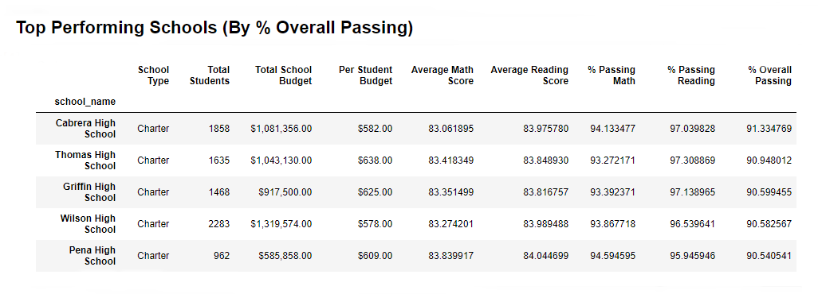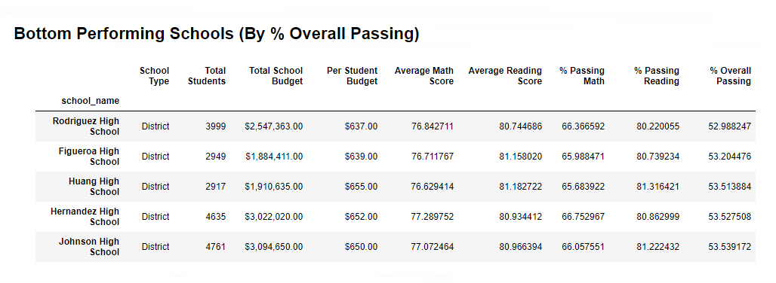

The second trend is that the district schools in this area are having average lower grades both in math and reading compared to their charter schools counterparts. They are especially struggling in math, where they only pass 66% of their students. This is despite having a significantly higher budget per student.

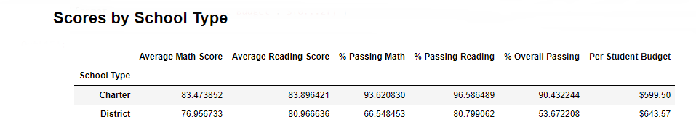

The third is that school size actually doesn’t affect the performance of the school that much, as some of the larger charter schools have size that only slightly smaller than the district schools, and yet they are performing very well and the largest of them; Wilson High School is the fourth best performing school, and the smallest one; Holden High School is not among the best.

